[ Insert official UPAEP logo ]
UPAEP · Decanato de Ingenierías
EVIDENCE — US13-T4
Test alert history
SmartGreenAI: Cilantro Crop

1. Task information
Task ID | US13-T4
User Story | US-13 — View alert history
Sprint | Sprint 3 (2026-10-12 – 2026-10-30)
Week | Week 3
Responsible | Carlos Ramirez Mendoza
Peer reviewer | Jorge Velez Delgado
Planned / actual hours | 1.5 h / 1.5 h
Completed on | October 29, 2026
Status | Done

2. Task description
Generate at least 20 alerts with the simulator and verify order, filters, export and access for each role.

3. Completion conditions
✓ Condition 1: At least 20 alerts were used.
How it was verified: The simulator (scenario "alerts") generated 24 alerts: every odd cycle leaves the range on SM-01, SM-02, TMP-01 and HUM-01 and every even cycle returns, so each alert was opened and resolved.
Alerts generated by the simulator run (scenario "alerts", 12 cycles) (first 10 of 24 rows; complete result in US13-T4_Test_Alert_History_2.csv)
id | sensor_id | type | severity | status | value | created_at | resolved_at
alr-ca7d6eed63ef | SM-01 | LOW | MEDIUM | RESOLVED | 55.3 | 2026-09-29T04:38:20.447Z | 2026-09-29T04:38:22.605Z
alr-51653b63bc4a | SM-02 | LOW | HIGH | RESOLVED | 54.8 | 2026-09-29T04:38:20.472Z | 2026-09-29T04:38:22.621Z
alr-dbf9a08bef35 | TMP-01 | HIGH | MEDIUM | RESOLVED | 26.4 | 2026-09-29T04:38:20.492Z | 2026-09-29T04:38:22.635Z
alr-4fa29c419a46 | HUM-01 | LOW | MEDIUM | RESOLVED | 45.5 | 2026-09-29T04:38:20.512Z | 2026-09-29T04:38:22.650Z
alr-cc77eacf95ea | SM-01 | LOW | MEDIUM | RESOLVED | 55.6 | 2026-09-29T04:38:24.759Z | 2026-09-29T04:38:26.912Z
alr-118345936b4a | SM-02 | LOW | MEDIUM | RESOLVED | 55.2 | 2026-09-29T04:38:24.784Z | 2026-09-29T04:38:26.928Z
alr-62b0e09619cd | TMP-01 | HIGH | MEDIUM | RESOLVED | 26.5 | 2026-09-29T04:38:24.803Z | 2026-09-29T04:38:26.943Z
alr-1694bde6e0ad | HUM-01 | LOW | HIGH | RESOLVED | 44.9 | 2026-09-29T04:38:24.824Z | 2026-09-29T04:38:26.959Z
alr-55b823422953 | SM-01 | LOW | MEDIUM | RESOLVED | 55.3 | 2026-09-29T04:38:29.047Z | 2026-09-29T04:38:31.190Z
alr-fd08afed5266 | SM-02 | LOW | HIGH | RESOLVED | 54.9 | 2026-09-29T04:38:29.069Z | 2026-09-29T04:38:31.205Z
SQL: SELECT id, sensor_id, type, severity, status, value, created_at, resolved_at FROM alerts WHERE created_at >= $1 ORDER BY created_at
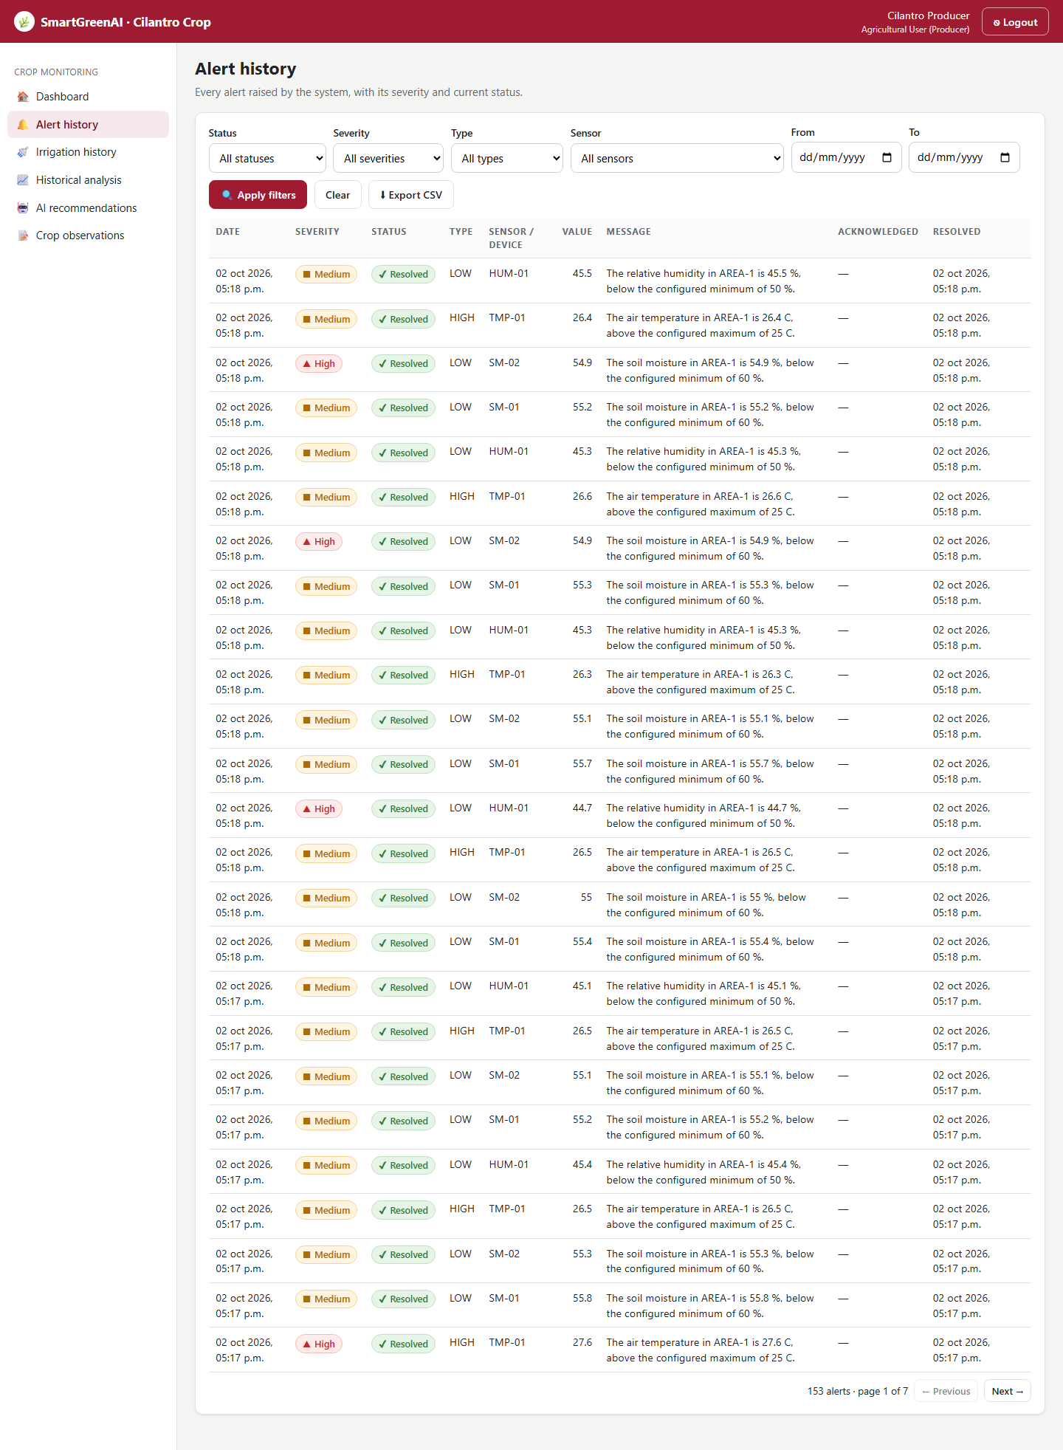
Figure US13-T4-1. Alert history with the 24 alerts generated by the simulator (newest first). (US13-T4_Test_Alert_History_4.png)
✓ Condition 2: Order, filters and export verified.
How it was verified: Order, filters and CSV export were verified on those alerts.
Order, filter and export (attached: US13-T4_Test_Alert_History_5.txt)
GET /api/alerts?from=2026-09-29T04%3A38%3A20.447Z&sensor_id=TMP-01&limit=100
Authorization: Bearer eyJhbG…
→ HTTP 200 OK (17 ms)
{
"total": 6,
"limit": 100,
"offset": 0,
"count": 6,
"data": [
{
"id": "alr-932299dc80d0",
"sensor_id": "TMP-01",
"device_id": null,
"area_id": "AREA-1",
"threshold_id": "th-a1-temperature",
… (134 more lines in the attached file)

✓ Condition 3: Access verified for every role.
How it was verified: Access verified for every role: producer → 200, admin → 200, superadmin → 200, anonymous → 401.
✓ Condition 4: Evidence: Test table with results and screenshots.
How it was verified: Test table with results and screenshots.

4. Alert history tests
ID | Case | Steps | Input | Expected | Actual | Result
AH-01 | Volume | Simulator scenario alerts, 12 cycles | 6 out-of-range cycles × 4 sensors | ≥ 20 alerts | 24 alerts (33 before the run) | PASS
AH-02 | Order | GET /alerts?from=start | 24 rows | newest first | descending created_at | PASS
AH-03 | Filter by sensor | GET /alerts?sensor_id=TMP-01 | TMP-01 | only TMP-01 | 6 rows, all TMP-01: true | PASS
AH-04 | Export | GET /alerts/export.csv with the same filter | TMP-01 | same rows as the list | 6 CSV rows vs 6 in the list | PASS
AH-05 | Access producer | GET /alerts | producer | 200 | HTTP 200 | PASS
AH-06 | Access admin | GET /alerts | admin | 200 | HTTP 200 | PASS
AH-07 | Access superadmin | GET /alerts | superadmin | 200 | HTTP 200 | PASS
AH-08 | Access anonymous | GET /alerts | anonymous | 401 | HTTP 401 | PASS
Totals: 8 cases · 8 PASS · 0 FAIL

5. Attached files
- US13-T4_Test_Alert_History_1.log
- US13-T4_Test_Alert_History_2.csv
- US13-T4_Test_Alert_History_3.sql
- US13-T4_Test_Alert_History_4.png
- US13-T4_Test_Alert_History_5.txt

6. Traceability
Related requirements | FR-15, FR-22
Implementation | —
Verification | integration/thresholds-alerts.test.js; Postman folder 07

7. Sign-off
Role | Name | Date | Signature
Responsible | Carlos Ramirez Mendoza | October 29, 2026
Peer reviewer | Jorge Velez Delgado | October 29, 2026
Product Owner acceptance | Alexis Enrique Valle Parra | October 29, 2026
Approval record: Sprint 3 Review & Delivery (October 30, 2026): "Product Owner accepted the seven user stories: all acceptance criteria met."

